GSC “Server error (5xx)”
Investigation & Validation Guide
LEDSone.co.uk — Internal SEO / Shopify Handover SOP
Purpose: A new SEO team member should be able to identify a 5xx indexing issue, test representative URLs, distinguish a historical/transient error from a current server problem, record evidence, and know when to start a new GSC validation.

1. What “Server error (5xx)” means
A 5xx issue means Google encountered a server-side failure while requesting a URL. Google describes server errors as situations where Googlebot could not access the URL, the request timed out, or the site was busy. A 5xx response can therefore prevent that URL from being indexed at that crawl.
Important: a 5xx shown in the Page indexing report is evidence from a previous Google crawl. It does not automatically prove that the same URL is still returning a 5xx today.

2. Current LEDSone report snapshot
GSC issue | Server error (5xx)
Affected pages in screenshot | 47
Validation status | Validation failed
Validation started | 24 Aug 2026
Validation failed | 15 Sep 2026
Report screenshot | Examples last crawled 10 Sep 2026
Screenshot evidence from the actual LEDSone GSC report:
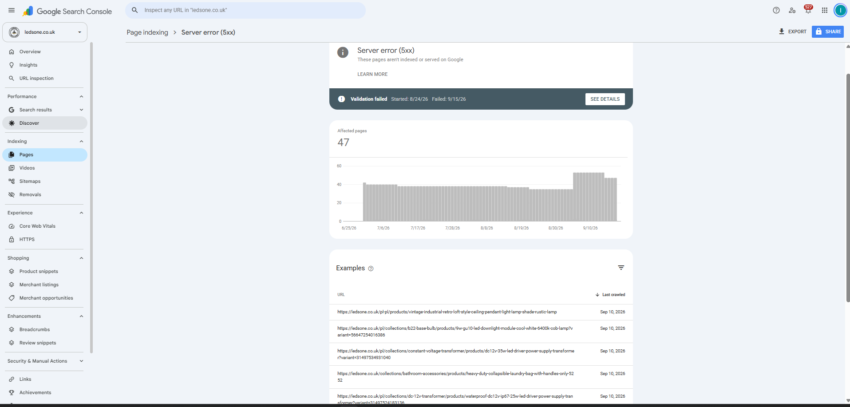
Figure 1 — LEDSone GSC → Page indexing → Server error (5xx): 47 affected pages.

3. The most important rule: Report ≠ Live Test
Use the Page indexing report to find the URLs and the URL Inspection Live Test to check the current state of a specific URL. Google explicitly notes that server errors can be transient: a live test may succeed even though an earlier Google crawl encountered a server error.
Therefore, never assume that all 47 URLs are still broken just because the report says 47.

4. Step-by-step investigation SOP

Step 1 — Open the report
GSC → Indexing → Pages → Why pages aren’t indexed → Server error (5xx).

Step 2 — Record the baseline
Record affected-page count, Last update date, validation status, validation start/fail dates, and several example URLs.

Step 3 — Select representative URLs
Do not test only one pattern. Select examples from different URL structures such as /pl/, /nl/, collection/product paths, and URLs containing ?variant=.

Step 4 — Inspect the exact URL
Open URL Inspection and inspect the URL exactly as listed in the report. Record the Google Index result and Last crawl date.

Step 5 — Run Test Live URL
Click TEST LIVE URL. This is the key check for whether Google can access the page now.

Step 6 — Read Page availability
Check Crawl allowed, Page fetch, and Indexing allowed. For a healthy page, Page fetch should be Successful.

Step 7 — If Live Test still returns a server error
Treat it as a current technical issue. Investigate the URL pattern, storefront behavior, recent theme/app changes, and any platform/hosting availability issue before validation.

Step 8 — If Live Test succeeds
Record that the reported 5xx may be historical/transient for that sample. Test additional representative URLs before concluding that the batch issue is recovered.

Step 9 — Verify the page itself
Open the URL in a normal browser and confirm it loads the intended page. Check for unexpected redirects, error pages, broken variants, or inconsistent behavior.

Step 10 — Re-test after any fix
Run Test Live URL again after the technical change. Save the evidence.

Step 11 — Start validation only after the issue is actually fixed
When the known 5xx instances have been fixed and representative testing is clean, use Start New Validation / Validate Fix.

Step 12 — Monitor
Do not repeatedly restart validation. Monitor Pending/Passed/Failed states and the report’s Last update date.

5. Testing decision matrix
GSC report | Live Test | Action
Server error (5xx) | Page fetch fails / 5xx | Current issue. Investigate and fix before validation.
Server error (5xx) | Page fetch successful | Likely recovered/transient for that URL. Test more representative URLs.
Server error (5xx) | Redirects | Investigate redirect behavior separately; do not classify it as a 5xx fix yet.
Server error (5xx) | Successful + URL indexed | Strong evidence that the old report is stale for that URL; continue batch sampling.

6. Testing example — LEDSone 5xx report
The actual report contains examples such as:
- https://ledsone.co.uk/pl/products/vintage-industrial-retro-loft-style-ceiling-pendant-light-lamp-shade-rustic-lamp
- https://ledsone.co.uk/pl/collections/b22-base-bulb/products/9w-gu10-led-downlight-module-cool-white-6400k-cob-lamp?variant=56647254016386
- https://ledsone.co.uk/pl/collections/constant-voltage-transformer/products/dc12v-35w-led-driver-power-supply-transformer?variant=31497534931040
Figure 2 — Example URLs shown by the 5xx report.
Testing procedure for one example: copy the exact URL → URL Inspection → inspect the Google Index result → click TEST LIVE URL → record Page availability → record Page fetch → compare with the old crawl date.

7. Testing example — successful Live Test interpretation
During the LEDSone investigation, a URL that had been reported in an indexing issue was tested live and Google returned “URL is available to Google” with “Page can be indexed” and a successful page fetch. This demonstrates the correct interpretation of a successful live test: Google can access the page now; it does not by itself prove that every URL in the 5xx report is fixed or indexed.
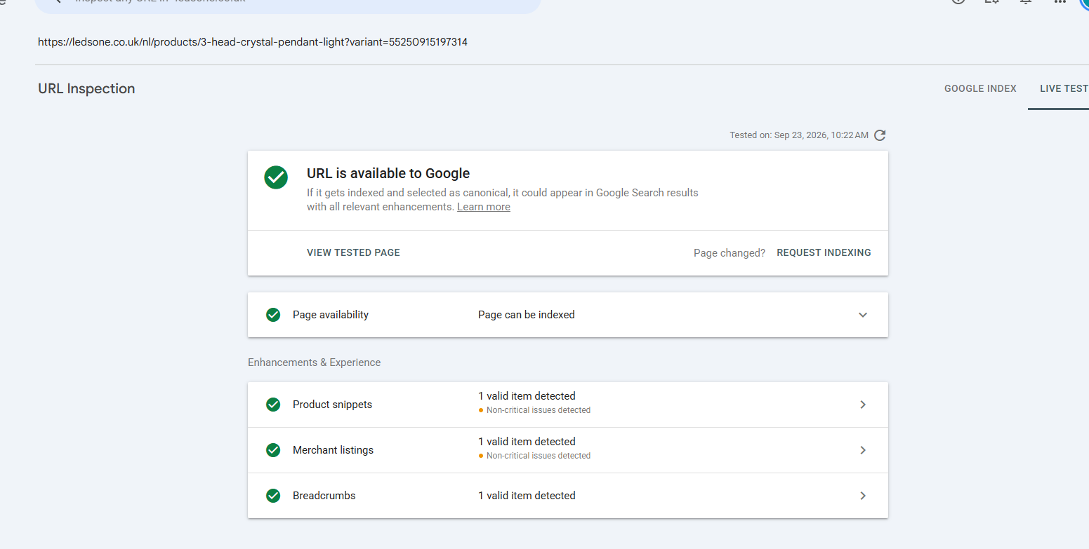
Figure 3 — Example of a successful GSC Live Test: URL available to Google / Page can be indexed.

8. What to check on Shopify when a 5xx is reproduced
- Open the exact URL in a browser and confirm whether the error is reproducible.
- Check whether the problem is limited to one market/language path such as /pl/ or /nl/.
- Check whether the problem appears only on collection/product URLs or URLs with ?variant=.
- Check whether the URL redirects unexpectedly.
- Check recent Shopify theme/app/configuration changes that could affect storefront rendering or routing.
- Check Shopify/platform availability or known incidents if multiple unrelated URLs fail at the same time.
- Check whether the failure is intermittent by repeating the live test later rather than assuming a single successful test proves full recovery.
- Record exact URLs, timestamps, screenshots, and the observed GSC verdict before making changes.

9. Request Indexing vs Validate Fix
Request Indexing is for asking Google to recrawl an individual important URL. It is not a replacement for fixing a batch 5xx problem.
For a 5xx batch issue, the normal workflow is: fix the technical problem → confirm representative URLs with Live Test → start validation for the issue. Do not request indexing for dozens of affected URLs one by one.

10. What “Start New Validation” does
Start New Validation tells Google to recheck URLs for the specific issue. It does not instantly index the URLs and does not itself repair the site.
Google's documentation says validation can take up to about two weeks and sometimes longer. Do not click Validate Fix repeatedly while a validation is already running.

11. Validation states — quick reference
- Pending — queued for validation.
- Passed — Google checked the instance and no longer found the issue.
- Failed — Google checked the instance and still found the issue.
- Other — Google could not reach the URL or the instance was otherwise no longer present, depending on the report.

12. What not to do
- Do not assume all 47 URLs are currently returning 5xx.
- Do not request indexing for every affected URL.
- Do not restart validation repeatedly.
- Do not change canonical tags, hreflang, robots.txt, or noindex rules merely because the report says 5xx.
- Do not treat a successful browser load as the only proof; verify with GSC Live Test.
- Do not close the issue until representative URL tests and the GSC report support the conclusion.

13. Handover checklist for a new SEO team member
☐ Record issue name and affected-page count.
☐ Record report Last update date.
☐ Record validation status and dates.
☐ Select representative URLs from different URL patterns.
☐ Inspect each sample in URL Inspection.
☐ Run Test Live URL.
☐ Record Crawl allowed / Page fetch / Indexing allowed.
☐ If 5xx persists, investigate/fix the current technical cause.
☐ If Live Test succeeds, test more samples before declaring recovery.
☐ After verified recovery, start validation once.
☐ Monitor validation and the report’s Last update date.
☐ Keep screenshots/evidence with the task record.

14. Evidence log template
Date | URL | Report status | Last crawl | Live test | Action | Evidence

15. Official reference
Google Search Console — Page indexing report and server errors:
https://support.google.com/webmasters/answer/7440203
Google Search Console — URL Inspection:
https://support.google.com/webmasters/answer/9012289

Internal rule: Fix the current technical problem first. Validate second. Indexing requests are for individual priority URLs, not a substitute for batch repair.

